

**CAPSTONE PROJECT REPORT**

**Report 4 – Software Design Document**

– Ho Chi Minh, September 2023 –

**Table of Contents**

I. Record of Changes 3

II. Software Design Document 4

1. System Design 4

1.1 System Architecture 4

1.2 Package Diagram 4

2. Database Design 8

2.1 Data Dictionary 10

3. Detailed Design 27

3.1 <Feature/Function Name1> 27

3.2 <Feature/Function Name2> 28

# I. Record of Changes

| **Date** | **A* M, D** | **In charge** | **Change Description** |
| --- | --- | --- | --- |
|  |  |  |  |
|  |  |  |  |
|  |  |  |  |
|  |  |  |  |
|  |  |  |  |
|  |  |  |  |
|  |  |  |  |
|  |  |  |  |
|  |  |  |  |
|  |  |  |  |
|  |  |  |  |
|  |  |  |  |
|  |  |  |  |

*A - Added M - Modified D - Deleted

# II. Software Design Document

## 1. System Design

### 1.1 System Architecture

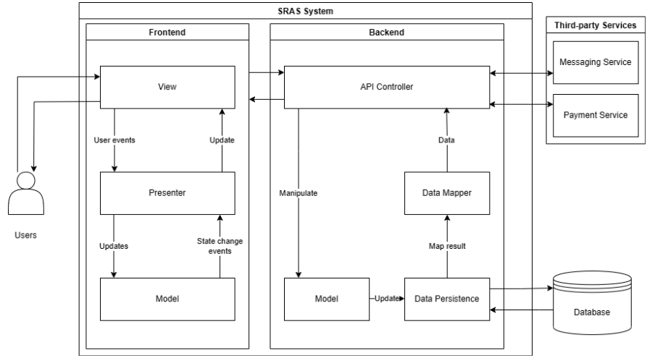

### 1.2 Package Diagram

#### 1.2.1 Back-end

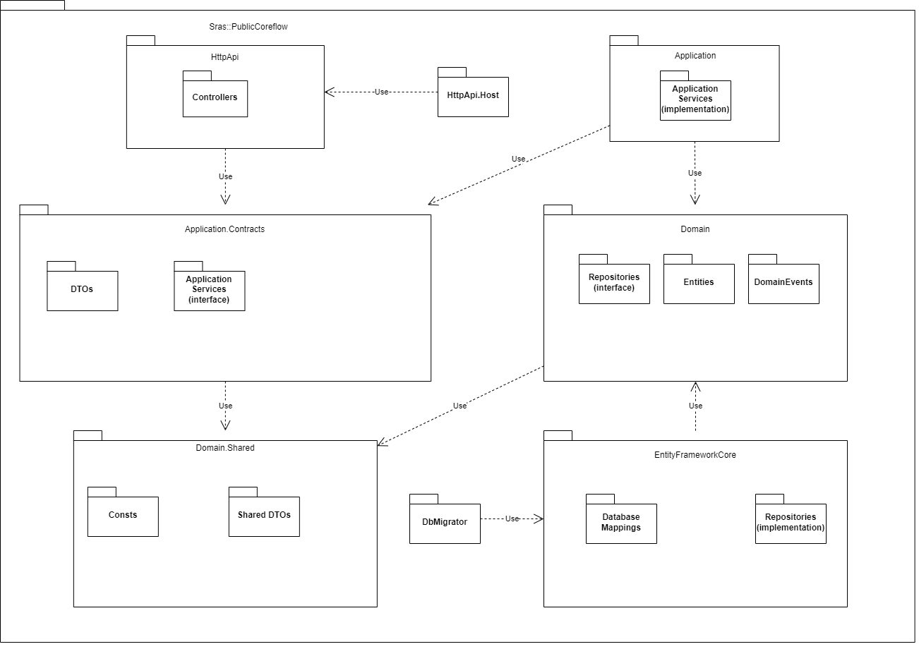

| **No** | **Package** | **Description** |
| --- | --- | --- |
| 1 | Consts | Contains classes for common constants shared by all other projects (layers) in the solution |
| 2 | SharedDTOs | Contains classes for common data transfer objects shared by all other projects (layers) in the solution |
| 3 | Domain.Shared | Is a thin project that contains some types that belong to the Domain layer, but are shared by all other layers |
| 4 | Repositories(interface) | Contains interfaces used by the Domain and Application layers to access to the data persistence system (the database) |
| 5 | Entities | Contains classes of models used by the application. |
| 6 | DomainEvents | Contains domain-specific event handlers of other registered services |
| 7 | Domain | Is the essential domain layer that contains all the building blocks (entities, repository interfaces, domain events) |
| 8 | DatabaseMappings | Contains the DbContext which includes mappings between entities and database tables |
| 9 | Repositories  (implementation) | Contains classes that implement interfaces from Repositories (interface) of Domain layer |
| 10 | EntityFrameworkCore | Is the essential integration package for the EF Core. |
| 11 | DbMigrator | Is a simple Console Application that migrates the database schema and seeds the initial data when you execute it. |
| 12 | DTOs | Contains classes for data transfer objects that transfer state (data) between the Application and Presentation Layers. |
| 13 | ApplicationServices(interface) | Contains the application service interfaces. |
| 14 | ApplicationContracts | Contains the application service interfaces and the DTOs used by these interfaces. This project can be shared by the client applications (including the UI). |
| 15 | ApplicationServices(implementation) | Contains classes that implement interfaces from ApplicationServices(interface) of Application layer |
| 16 | Application | Is the essential application layer that implements the interfaces defined in the Contracts project. |
| 17 | Controllers | Contains MVC Controllers. |
| 18 | HttpApi | Is a project containing HTTP APIs defined by the solution. It typically contains MVC Controllers and related models. |
| 19 | HttpApi.Host | Is the project to host the application. |

#### 1.2.2 Front-end

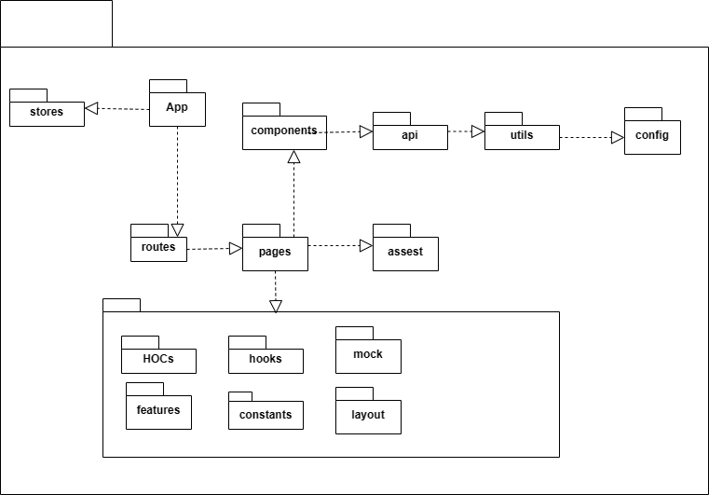

| **No** | **Package** | **Description** |
| --- | --- | --- |
| 1 | app | The package contains files responsible for running web applications. |
| 2 | store | The package contains files responsible for sharing states used in the application. |
| 3 | routes | The package contains files responsible for the structure of web application routing. |
| 4 | pages | The package contains files responsible for the structure of user interface corresponding suitable routing. |
| 5 | api | The package contains files responsible for sending HTTP requests and receiving server responses. |
| 6 | utils | The package contains files responsible for common functions. |
| 7 | config | The package contains files responsible for configuration of application. |
| 8 | asset | The package contains files responsible for images and files such as pdf, docx. |
| 9 | HOCs | The package contains a file responsible for showing toast message. |
| 10 | hooks | The package contains files responsible for custom hooks used for modifying and get data from global state. |
| 11 | mock | The package contains files responsible for default data. |
| 12 | features | The package contains files responsible for getting global state and modifying global state. |
| 13 | constants | The package contains files responsible for constants used in application. |
| 14 | layout | The package contains files responsible for layout of user interface. |
| 15 | components | The package contains files responsible for common user interface components and combined to create a completed user interface. |

## 2. Database Design

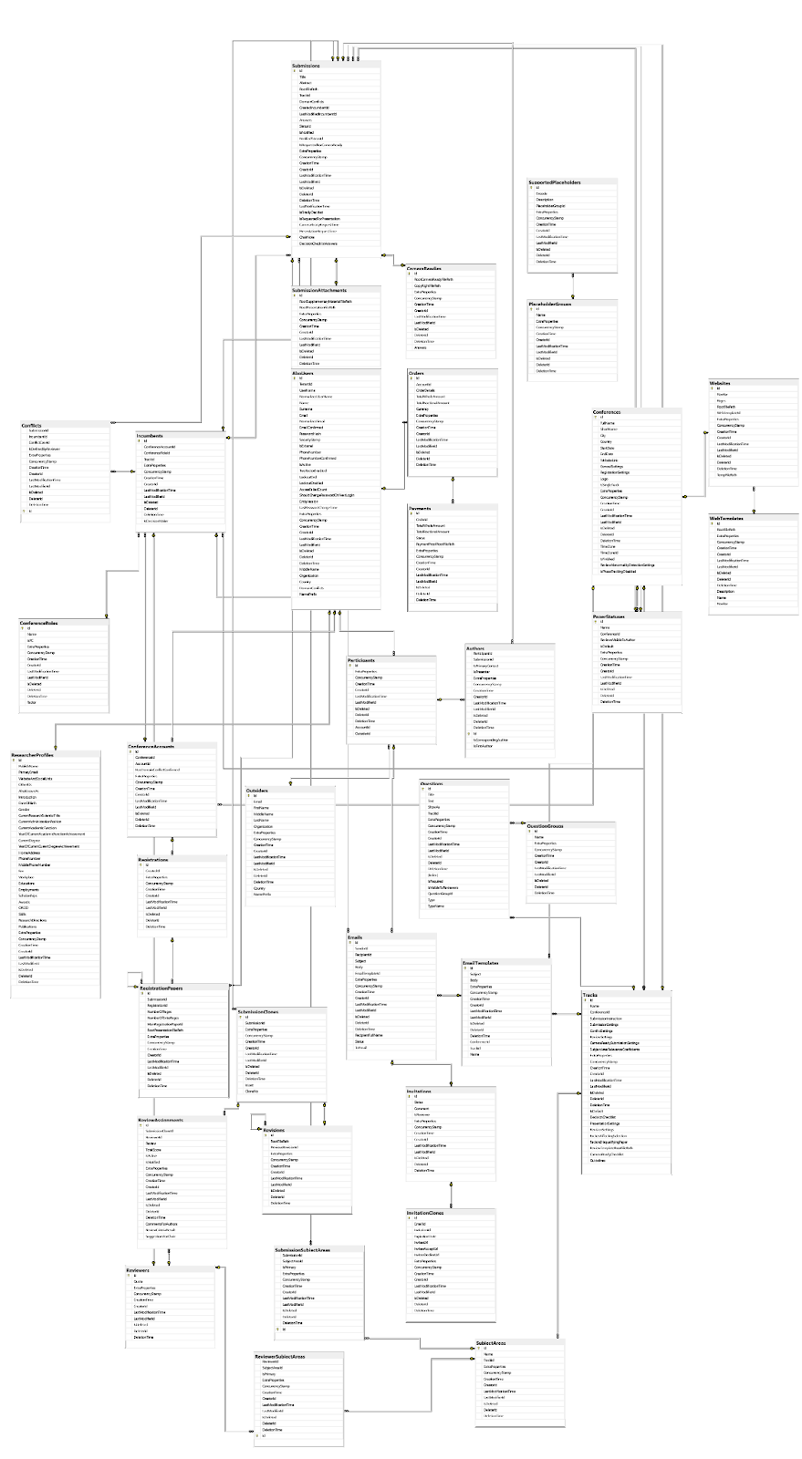

### 2.1 Data Dictionary

**AbpUsers**

| **Field name** | **Type** | **Not null** | **PK/FK** | **Unique** |
| --- | --- | --- | --- | --- |
| Id | UUID | X | PK | X |
| UserName | UUID | X |  | X |
| Name | nvarchar(64) |  |  |  |
| MiddleName | nvarchar(64) |  |  |  |
| Surname | nvarchar(64) |  |  |  |
| Email | nvarchar(256) | X |  | X |
| EmailConfirmed | bit | X |  |  |
| Organization | nvarchar(128) |  |  |  |
| PasswordHash | nvarchar(256) |  |  |  |
| Country | nvarchar(64) |  |  |  |
| DomainConflicts | nvarchar(1024) |  |  |  |

**ActivityDeadline**

| **Field name** | **Type** | **Not null** | **PK/FK** | **Unique** |
| --- | --- | --- | --- | --- |
| Id | UUID | X | PK | X |
| Name | nvarchar(64) | X |  |  |
| Status | tinyint | X |  |  |
| Deadline | datetime2(7) |  |  |  |
| TrackId | UUID | X | FK |  |

**Authors**

| **Field name** | **Type** | **Not null** | **PK/FK** | **Unique** |
| --- | --- | --- | --- | --- |
| Id | UUID | X | PK | X |
| ParticipantId | UUID | X |  | X |
| SubmissionId | UUID |  |  |  |
| IsPrimaryContact | bit | X |  |  |
| IsPresenter | bit | X |  |  |

**CameraReadies**

| **Field name** | **Type** | **Not null** | **PK/FK** | **Unique** |
| --- | --- | --- | --- | --- |
| Id | UUID | X | PK | X |
| RootCameraReadyFilePath | varchar(1024) |  |  |  |
| CopyRightFilePath | varchar(1024) |  |  |  |
| Answers | nvarchar(max) |  |  |  |

**ConferenceAccount**

| **Field name** | **Type** | **Not null** | **PK/FK** | **Unique** |
| --- | --- | --- | --- | --- |
| Id | UUID | X | PK | X |
| ConferenceId | UUID | X | FK | X |
| AccountId | UUID | X | FK |  |
| HasDomainConflictConfirmed | bit |  |  |  |

**ConferenceRole**

| **Field name** | **Type** | **Not null** | **PK/FK** | **Unique** |
| --- | --- | --- | --- | --- |
| Id | UUID | X | PK | X |
| Name | varchar(50) | X |  |  |
| IsPC | bit | X |  |  |
| Factor | int | X |  |  |

**Conferences**

| **Field name** | **Type** | **Not null** | **PK/FK** | **Unique** |
| --- | --- | --- | --- | --- |
| Id | UUID | X | PK | X |
| FullName | varchar(200) | X |  |  |
| ShortName | nvarchar(50) | X |  |  |
| City | nvarchar(100) | X |  |  |
| Country | nvarchar(100) | X |  |  |
| StartDate | datetime | X |  |  |
| EndDate | datetime | X |  |  |
| WebsiteLink | nvarchar(max) |  |  |  |
| GeneralSettings | nvarchar(max) |  |  |  |
| RegistrationSettings | nvarchar(max) |  |  |  |
| Logo | nvarchar(max) | X |  |  |
| IsSingleTrack | bit | X |  |  |

**ConflictCases**

| **Field name** | **Type** | **Not null** | **PK/FK** | **Unique** |
| --- | --- | --- | --- | --- |
| Id | UUID | X | PK | X |
| Name | nvarchar(128) | X |  |  |
| IsIndividual | bit | X |  |  |
| IsDefault | bit | X |  |  |
| TrackId | UUID |  | FK |  |

**Conflict**

| **Field name** | **Type** | **Not null** | **PK/FK** | **Unique** |
| --- | --- | --- | --- | --- |
| Id | UUID | X | PK | X |
| SubmissionId | UUID | X | FK |  |
| IncumbentId | UUID | X | FK |  |
| ConflictCaseId | UUID | X | FK |  |
| IsDefinedByReviewer | bit | X |  |  |

**Emails**

| **Field name** | **Type** | **Not null** | **PK/FK** | **Unique** |
| --- | --- | --- | --- | --- |
| Id | UUID | X | PK | X |
| SenderId | UUID | X | FK |  |
| RecipientId | UUID | X | FK |  |
| Subject | nvarchar(2048) | X |  |  |
| Body | nvarchar(max) | X |  |  |
| EmailTemplateId | UUID | X | FK |  |
| RecipientFullName | nvarchar(192) |  |  |  |
| Status | nvarchar(256) |  |  |  |
| ToEmail | nvarchar(256) |  |  |  |

**EmailTemplate**

| **Field name** | **Type** | **Not null** | **PK/FK** | **Unique** |
| --- | --- | --- | --- | --- |
| Id | UUID | X | PK | X |
| Name | nvarchar(1024) | X |  |  |
| Subject | nvarchar(1024) | X |  |  |
| Body | nvarchar(max) | X |  |  |
| ConferenceId | UUID |  | FK |  |
| TrackId | UUID |  | FK |  |

**Guidelines**

| **Field name** | **Type** | **Not null** | **PK/FK** | **Unique** |
| --- | --- | --- | --- | --- |
| Id | UUID | X | PK | X |
| Name | nvarchar(64) | X |  |  |
| Description | nvarchar(1024) |  |  |  |
| GuidelineGroup | nvarchar(64) | X |  |  |
| IsChairOnly | bit | X |  |  |
| Route | nvarchar(1024) |  |  |  |
| Factor | int | X |  |  |
| ConsoleFigures | nvarchar(max) |  |  |  |
| ConsoleUIColumns | nvarchar(max) |  |  |  |
| IsFinishedMarkingGuideline | bit | X |  |  |

**Incumbent**

| **Field name** | **Type** | **Not null** | **PK/FK** | **Unique** |
| --- | --- | --- | --- | --- |
| Id | UUID | X | PK | X |
| ConferenceAccountId | UUID | X | FK |  |
| ConferenceRoleId | UUID | X | FK |  |
| TrackId | UUID |  | FK |  |
| IsDecisionMaker | bit | X |  |  |

**InvitationClones**

| **Field name** | **Type** | **Not null** | **PK/FK** | **Unique** |
| --- | --- | --- | --- | --- |
| Id | UUID | X | PK | X |
| EmailId | UUID | X | FK |  |
| InvitationId | UUID | X | FK |  |
| ExpirationDate | datetime | X |  |  |
| InviteeUrl | nvarchar(2048) | X |  |  |
| InviteeAcceptUrl | nvarchar(2048) | X |  |  |
| InviteeDeclineUrl | nvarchar(2048) | X |  |  |

**Invitations**

| **Field name** | **Type** | **Not null** | **PK/FK** | **Unique** |
| --- | --- | --- | --- | --- |
| Id | UUID | X | PK | X |
| Status | nvarchar(128) | X |  |  |
| Comment | nvarchar(2048) |  |  |  |
| IsReviewer | bit | X |  |  |

**Orders**

| **Field name** | **Type** | **Not null** | **PK/FK** | **Unique** |
| --- | --- | --- | --- | --- |
| Id | UUID | X | PK | X |
| AccountId | UUID | X | FK |  |
| OrderDetails | nvarchar(max) | X |  |  |
| TotalWholeAmount | int | X |  |  |
| TotalFractionalAmount | int | X |  |  |
| Currency | nvarchar(64) | X |  |  |

**Outsiders**

| **Field name** | **Type** | **Not null** | **PK/FK** | **Unique** |
| --- | --- | --- | --- | --- |
| Id | UUID | X | PK | X |
| Email | varchar(256) | X |  | X |
| FirstName | nvarchar(64) | X |  |  |
| MiddleName | nvarchar(64) |  |  |  |
| LastName | nvarchar(64) | X |  |  |
| Organization | nvarchar(256) |  |  |  |
| Country | nvarchar(64) | X |  |  |
| NamePrefix | nvarchar(32) |  |  |  |

**PaperStatuses**

| **Field name** | **Type** | **Not null** | **PK/FK** | **Unique** |
| --- | --- | --- | --- | --- |
| Id | UUID | X | PK | X |
| Name | nvarchar(50) | X |  |  |
| ConferenceId | UUID |  | FK |  |
| ReviewsVisibleToAuthor | bit | X |  |  |
| IsDefault | bit | X |  |  |

**Participant**

| **Field name** | **Type** | **Not null** | **PK/FK** | **Unique** |
| --- | --- | --- | --- | --- |
| Id | UUID | X | PK | X |
| AccountId | UUID |  | FK |  |
| OutsiderId | UUID |  | FK |  |

**Payments**

| **Field name** | **Type** | **Not null** | **PK/FK** | **Unique** |
| --- | --- | --- | --- | --- |
| Id | UUID | X | PK | X |
| OrderId | varchar(20) | X | FK |  |
| TotalWholeAmount | int | X |  |  |
| TotalFractionalAmount | int | X |  |  |
| Status | nvarchar(64) | X |  |  |
| PaymentProofRootFilePath | nvarchar(1024) |  |  |  |

**PlaceholderGroups**

| **Field name** | **Type** | **Not null** | **PK/FK** | **Unique** |
| --- | --- | --- | --- | --- |
| Id | UUID | X | PK | X |
| Name | varchar(128) | X | FK |  |

**QuestionGroups**

| **Field name** | **Type** | **Not null** | **PK/FK** | **Unique** |
| --- | --- | --- | --- | --- |
| Id | UUID | X | PK | X |
| Name | varchar(256) | X |  |  |

**Question**

| **Field name** | **Type** | **Not null** | **PK/FK** | **Unique** |
| --- | --- | --- | --- | --- |
| Id | UUID | X | PK | X |
| Title | nvarchar(2048) | X |  |  |
| ShowAs | nvarchar(max) | X |  |  |
| Text | nvarchar(2048) |  |  |  |
| QuestionGroupId | UUID | X | FK |  |
| TrackId | UUID | X | FK |  |
| IsRequired | bit | X |  |  |
| IsVisibleToReviewers | bit |  |  |  |
| Type | nvarchar(64) | X |  |  |
| TypeName | nvarchar(64) | X |  |  |

**RegistrationPapers**

| **Field name** | **Type** | **Not null** | **PK/FK** | **Unique** |
| --- | --- | --- | --- | --- |
| Id | UUID | X | PK | X |
| SubmissionId | UUID | X | FK |  |
| RegistrationId | UUID | X | FK |  |
| NumberOfPages | int | X |  |  |
| NumberOfExtraPages | int | X |  |  |
| MainRegistraationPaperId | UUID | X |  |  |
| RootPresentationFilePath | nvarchar(1024) | X |  |  |

**Registration**

| **Field name** | **Type** | **Not null** | **PK/FK** | **Unique** |
| --- | --- | --- | --- | --- |
| Id | UUID | X | PK | X |
| CreatedId | varchar(20) | X | FK |  |

**ResearcherProfiles**

| **Field name** | **Type** | **Not null** | **PK/FK** | **Unique** |
| --- | --- | --- | --- | --- |
| Id | UUID | X | PK | X |
| PublishName | UUID | X |  |  |
| PrimaryEmail | UUID | X |  |  |
| WebsiteAndSocialLinks | int |  |  |  |
| OtherIDs | int |  |  |  |
| AlsoKnownAs | UUID |  |  |  |
| Introduction | nvarchar(1024) |  |  |  |
| DateOfBirth | datetime | X |  |  |
| Gender | nvarchar(64) | X |  |  |
| CurrentResearchScientistTitle | nvarchar(512) |  |  |  |
| CurrentAdministrationPosition | datetime |  |  |  |
| CurrentAcademicFunction | nvarchar(64) |  |  |  |
| YearOfCurrentAcademicFunctionAchievement | int |  |  |  |
| CurrentDegree | nvarchar(512) |  |  |  |
| YearOfCurrentDegreeAchievement | int |  |  |  |
| HomeAddress | nvarchar(512) |  |  |  |
| PhoneNumber | nvarchar(16) |  |  |  |
| MobilePhoneNumber | nvarchar(16) |  |  |  |
| Fax | nvarchar(32) |  |  |  |
| Workplace | nvarchar(max) |  |  |  |
| Educations | nvarchar(max) |  |  |  |
| Employments | nvarchar(max) |  |  |  |
| Scholarships | nvarchar(max) |  |  |  |
| Awards | nvarchar(max) |  |  |  |
| ORCID | nvarchar(max) |  |  |  |
| Skills | nvarchar(max) |  |  |  |
| ResearchDirections | nvarchar(max) |  |  |  |
| Publications | nvarchar(max) |  |  |  |

**ReviewAssignments**

| **Field name** | **Type** | **Not null** | **PK/FK** | **Unique** |
| --- | --- | --- | --- | --- |
| Id | UUID | X | PK | X |
| SubmissionCloneId | UUID | X | FK |  |
| ReviewerId | UUID | X | FK |  |
| Review | int |  |  |  |
| TotalScore | int |  |  |  |
| IsActive | UUID | X |  |  |
| IsNotified | nvarchar(1024) | X |  |  |
| CommentsForAuthors | datetime |  |  |  |
| ReviewCriteriaResult | nvarchar(64) |  |  |  |
| SuggestionsForChair | nvarchar(512) |  |  |  |

**Reviewers**

| **Field name** | **Type** | **Not null** | **PK/FK** | **Unique** |
| --- | --- | --- | --- | --- |
| Id | UUID | X | PK | X |
| Quota | int |  |  |  |

**ReviewerSubjectAreas**

| **Field name** | **Type** | **Not null** | **PK/FK** | **Unique** |
| --- | --- | --- | --- | --- |
| Id | UUID | X | PK | X |
| ReviewerId | UUID | X | FK |  |
| SubjectAreaId | UUID | X | FK |  |
| IsPrimary | bit | X |  |  |

**Revisions**

| **Field name** | **Type** | **Not null** | **PK/FK** | **Unique** |
| --- | --- | --- | --- | --- |
| Id | UUID | X | PK | X |
| RootFilePath | varchar(1024) |  |  |  |
| PreviousRevisionId | UUID |  | FK |  |

**SubjectAreas**

| **Field name** | **Type** | **Not null** | **PK/FK** | **Unique** |
| --- | --- | --- | --- | --- |
| Id | UUID | X | PK | X |
| Name | nvarchar(512) |  |  |  |
| TrackId | UUID | X | FK |  |

**SubmissionAttachments**

| **Field name** | **Type** | **Not null** | **PK/FK** | **Unique** |
| --- | --- | --- | --- | --- |
| Id | UUID | X | PK | X |
| RootSupplementaryMaterialFilePath | nvarchar(1024) |  |  |  |
| RootPresentationFilePath | nvarchar(1024) |  |  |  |

**SubmissionClones**

| **Field name** | **Type** | **Not null** | **PK/FK** | **Unique** |
| --- | --- | --- | --- | --- |
| Id | UUID | X | PK | X |
| SubmissionId | varchar(20) | X |  | X |
| IsLast | bit |  |  |  |
| CloneNo | int |  |  |  |

**Submissions**

| **Field name** | **Type** | **Not null** | **PK/FK** | **Unique** |
| --- | --- | --- | --- | --- |
| Id | UUID | X | PK | X |
| Title | nvarchar(1024) | X |  |  |
| Abstract | nvarchar(2048) | X |  |  |
| RootFilePath | nvarchar(1024) |  |  |  |
| TrackId | UUID |  | FK |  |
| DomainConflicts | nvarchar(1024) |  |  |  |
| CreatedIncumbentId | UUID |  | FK |  |
| LastModifiedIncumbentId | UUID |  | FK |  |
| Answers | nvarchar(max) |  |  |  |
| StatusId | UUID | X | FK |  |
| IsNotified | bit |  |  |  |
| NotifiedStatusId | UUID |  | FK |  |
| LastNotificationTime | datetime |  |  |  |
| IsFinallyDecided | bit | X |  |  |
| IsRequestForCameraReady | bit | X |  |  |
| CameraReadyRequestTime | datetime | X |  |  |
| IsRequestedForPresentation | bit | X |  |  |
| PresentationRequestTime | datetime |  |  |  |
| ChairNote | nvarchar(max) |  |  |  |
| DecisionChecklistAnswers | nvarchar(max) |  |  |  |

**SubmissionSubjectAreas**

| **Field name** | **Type** | **Not null** | **PK/FK** | **Unique** |
| --- | --- | --- | --- | --- |
| Id | UUID | X | PK | X |
| SubmissionId | varchar(20) | X |  | X |
| SubjectAreaId |  |  |  |  |
| IsPrimary |  |  |  |  |

**SupportedPlaceholders**

| **Field name** | **Type** | **Not null** | **PK/FK** | **Unique** |
| --- | --- | --- | --- | --- |
| Id | UUID | X | PK | X |
| Encode | nvarchar(128) | X |  |  |
| Description | nvarchar(1024) | X |  |  |
| PlaceholderGroupId | UUID | X | FK |  |

**Tracks**

| **Field name** | **Type** | **Not null** | **PK/FK** | **Unique** |
| --- | --- | --- | --- | --- |
| Id | UUID | X | PK | X |
| Name | nvarchar(50) | X |  |  |
| ConferenceId | UUID | X |  |  |
| SubmissionInstruction | nvarchar(2000) |  |  |  |
| SubmissionSettings | nvarchar(max) |  |  |  |
| ConflictSettings | nvarchar(max) |  |  |  |
| ReviewSettings | nvarchar(max) |  |  |  |
| CameraReadySubmissionSettings | nvarchar(max) |  |  |  |
| SubjectAreaRelevanceCoeffcients | nvarchar(max) |  |  |  |
| IsDefault | nvarchar(max) |  |  |  |
| DecisionChecklist | nvarchar(max) |  |  |  |
| PresentationSettings | nvarchar(max) |  |  |  |
| RevisionSettings | nvarchar(max) |  |  |  |
| FactorsAffectingSelection | nvarchar(max) |  |  |  |
| FactorsDisqualifyingPaper | nvarchar(max) |  |  |  |
| ReviewTemplateRootFilePath | nvarchar(max) |  |  |  |
| CameraReadyChecklist | nvarchar(max) |  |  |  |
| Guidelines | nvarchar(max) |  |  |  |

**Website**

| **Field name** | **Type** | **Not null** | **PK/FK** | **Unique** |
| --- | --- | --- | --- | --- |
| Id | UUID | X | PK | X |
| Navbar | nvarchar(max) |  |  |  |
| Pages | nvarchar(max) |  |  |  |
| RootFilePath | nvarchar(1024) |  |  |  |
| TempFilePath | nvarchar(1024) |  |  |  |
| WebTemplateId | UUID | X | FK |  |

**WebTemplate**

| **Field name** | **Type** | **Not null** | **PK/FK** | **Unique** |
| --- | --- | --- | --- | --- |
| Id | UUID | X | PK | X |
| Name | varchar(20) | X |  | X |
| Description |  |  |  |  |
| RootFilePath |  |  |  |  |

**QuestionGroupTrack**

| **Field name** | **Type** | **Not null** | **PK/FK** | **Unique** |
| --- | --- | --- | --- | --- |
| Id | UUID | X | PK | X |
| QuestionGroupId | UUID | X |  | X |
| TrackId |  |  |  |  |
| Settings |  |  |  |  |

**InvitationClones**

| **Field name** | **Type** | **Not null** | **PK/FK** | **Unique** |
| --- | --- | --- | --- | --- |
| Id | UUID | X | PK | X |
| EmailId | UUID | X | FK |  |
| InvitationId | UUID | X | FK |  |
| ExpirationDate | datetime | X |  |  |
| InviteeUrl | nvarchar(2048) | X |  |  |
| InviteeAcceptUrl | nvarchar(2048) | X |  |  |
| InviteeDeclineUrl | nvarchar(2048) | X |  |  |

**SubmissionClones**

| **Field name** | **Type** | **Not null** | **PK/FK** | **Unique** |
| --- | --- | --- | --- | --- |
| Id | UUID | X | PK | X |
| SubmissionId | UUID | X | FK |  |
| IsLast | bit | X |  |  |
| CloneNo | int | X |  |  |

**SubmissionSubjectAreas**

| **Field name** | **Type** | **Not null** | **PK/FK** | **Unique** |
| --- | --- | --- | --- | --- |
| Id | UUID | X | PK | X |
| SubmissionId | UUID | X | FK |  |
| SubjectAreaId | UUID | X | FK |  |
| IsPrimary | bit | X |  |  |

**WebTemplates**

| **Field name** | **Type** | **Not null** | **PK/FK** | **Unique** |
| --- | --- | --- | --- | --- |
| Id | UUID | X | PK | X |
| Name | nvarchar(128) | X |  |  |
| RootFilePath | nvarchar(1024) | X |  |  |
| Description | nvarchar(1024) |  |  |  |
| Navbar | nvarchar(max) |  |  |  |

## 3. Detailed Design

#### 3.1.1 Class Diagram

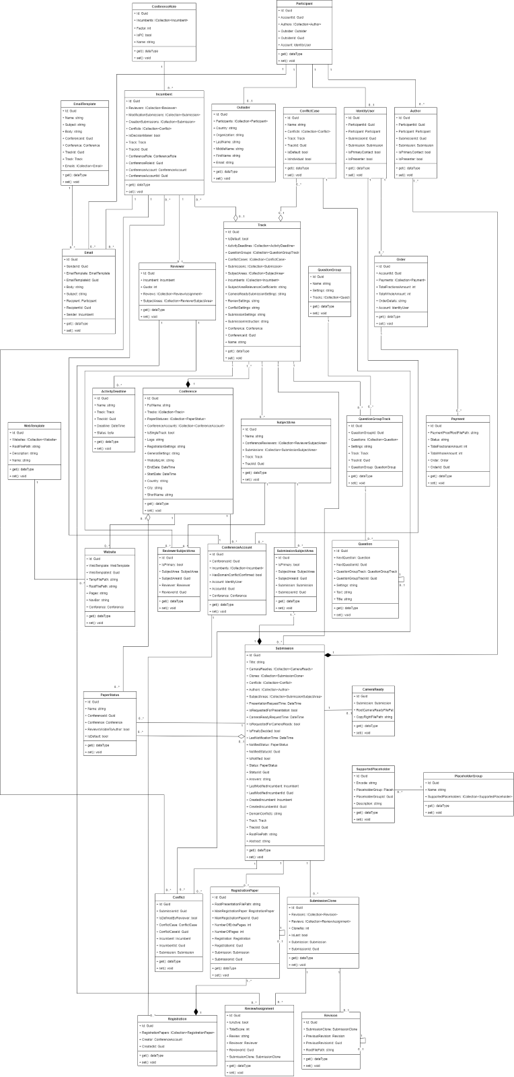

***3.1.2 Sequence Diagram***

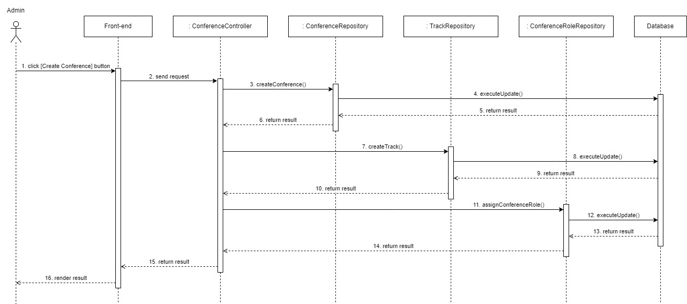

Create Conference – Sequence Diagram

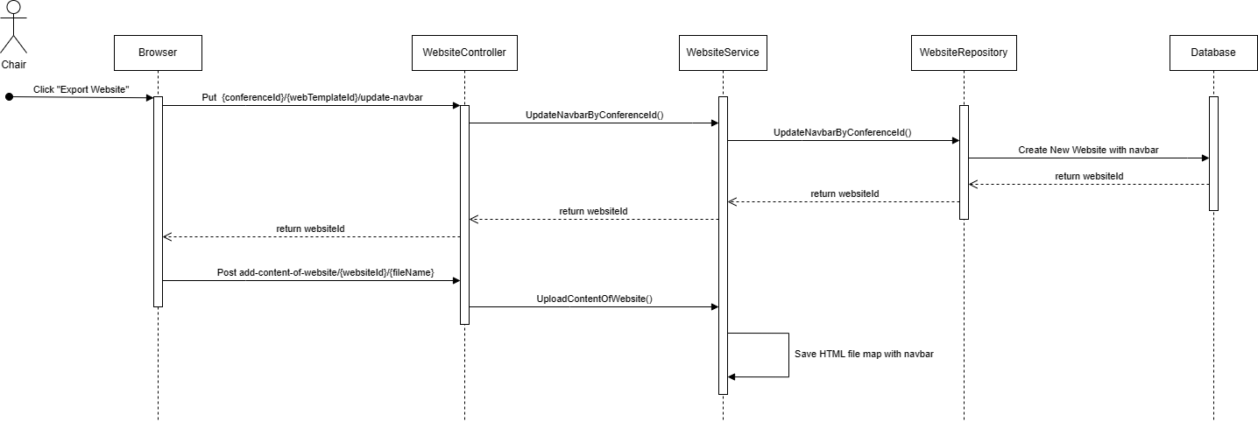

Create Conference Website – Sequence Diagram

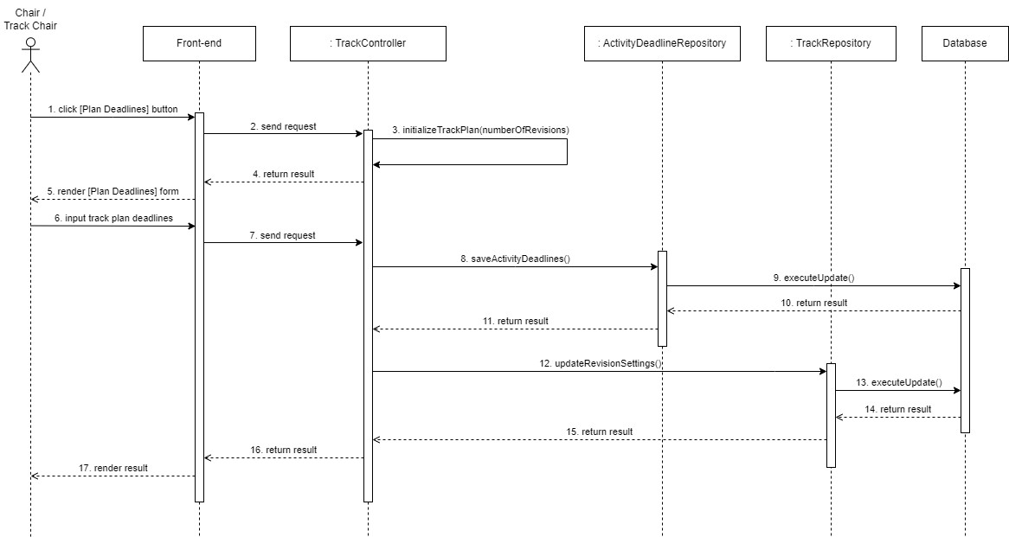

Create Track Plan – Sequence Diagram

**3.1.3 State Diagram**

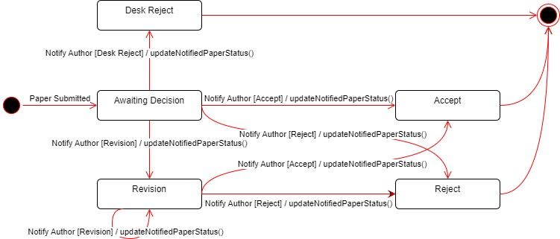

Notified Statuses State Diagram